A APC Lab Project Report

On

**“SOUND REACTIVE LED”**

Submitted in Partial Fulfilment of the Requirements

For the award of the Degree of

**Bachelor of Technology**

**In**

**Electronics & Computer Engineering (ECM)**

By

**P. TAPASWINI (20311A1987)**

**S. SWARNA (20311A1989)**

**K. SWETHA (20311A1990)**

Under the supervision of

**“Dr. Manu Gupta”**

#### 

**Department of Electronics & Computer Engineering**

**Sreenidhi Institute of Science & Technology (Autonomous)**

**2021-2022**

**DEPARTMENT OF ELECTRONICS & COMPUTER ENGINEERING**

**SREENIDHI INSTITUTE OF SCIENCE & TECHNOLOGY (AUTONOMOUS)**



**CERTIFICATE**

This is to certify that the EDC Lab Project work entitled “**SOUND REACTIVE LED”**, submitted by  **P TAPASWINI, S SWARNA, K SWETHA (20311A1987, 20311A1989, 20311A1990)** towards partial fulfilment for the award of Bachelor of Technology Degree in in **Electronics and Computer Engineering** in Sreenidhi Institute of Science & Technology, Ghatkesar, Hyderabad, is a record of bonafide work done by him/ her during the academic year 2021-2022 under our guidence and evaluation.

**Dr. Manu Gupta Mrs. K.Aruna Kumari**

**Lab Project Coordinator-1 Lab Project Coordinator-2**

**declaration**

This is to certify that the Technical Seminar Report titled “**SOUND REACTIVE LED**”, is a record work done by us in the department of Electronics and Computer Engineering (ECM), Sreenidhi Institute of Science & Technology, Ghatkesar, Hyderabad.

The report is based on the seminar work done entirely by us and not copied from any other source.

.

**Name of student (Roll No.)**

**P TaPASWINI 20311a1987**

**S SWARNA 20311a1989**

**K SWETHA 20311a1990**

**ACKNOWLEDGMENT**

I wish to express immense gratitude to my supervisor**, Dr. Manu Gupta**, ECM Department, for her able guidance and useful suggestions, who helped me in completing my project in time. Her valuable suggestions and comments towards this project have been very much helpful in tackling various obstacles and accomplishing the major tasks.

I take immense pleasure in thanking HOD **Dr.D. Mohan**, Principal **Dr. Shiva Reddy** and our Executive Director **Prof. CV. Tomy** and all faculty members of ECM department for having permitted me to carry out this project work.

Last but not least I would like to express my heartful thanks to my beloved parents for their blessings, friends, and classmates for their help and wishes for the successful completion of the project work.

**Name of student (Roll No.)**

**P TAPASWINI 20311a1987**

**S SWARNA 20311a1989**

**K SWETHA 20311a1990**

**ABSTRACT**

The light which glows according to the rhythm of the music is interesting to watch. Researchers founded that the unclear lights speeds up the brain waves that develops the higher concentration levels. This project is implemented in such a way that the lights (LED's) glow according to the music. The rhythm following lights can be achieved by this system This system uses a microphone through which, the audio input is picked up and amplified. Then this amplified signal triggers the sequence of LED's through an intermediate circuit. Hence the flashing of the LED's is done when an audio input is constantly changing its beat. So a Beautiful scenario of the changing LED's can be viewed with following led's which blinks the changing beat of the music. Further the project can enhanced by using triacs and opto-isolators to use high power lamps in place of LEDS

**INDEX**

|  |  |  |
| --- | --- | --- |
| S.NO | CONTENT | PAGE NUMBER |
| 1 | Introduction | 1 |
| 2 | Objective | 2 |
| 3 | Hardware Requirements and Description | 3-6 |
| 4 | Background Theory | 7 |
| 5 | Circuit / Block Diagram | 8 |
| 6 | Working | 9 |
| 7 | Results and Output | 10-11 |
| 8 | Conclusion | 12 |
| 9 | References | 13 |

**LIST OF FIGURES**

Figure 3.1 : Breadboard 3

Figure 3.2: connecting wires 3

Figure 3.3: condenser mic 4

Figure 3.4 : Battery(9v) 4

Figure 3.5: Transistor 5

Figure 3.6: LED 5

Figure 3.7 resistor 6

Figure 5.1: Circuit diagram 8

Figure 7.1: Sound Reactive LED connection 10

Figure 7.2: Sound Reactive LED output 11

Figure 7.3: Sound Reactive LED output 11

**CHAPTER 1  
INTRODUCTION**

Sound Reactive LED is made with the help of condenser microphone, which senses the sound as input and processes it to the circuit in order to give the Output. When sound is given as the input to the Electric Condenser microphone, it is changed into the Electrical Energy which turns on led and led will turns off automatically after few seconds. The condenser microphone picks up the sound of your claps, coughs, and the sound of that book knocked off the table. It produces a small electrical signal which is amplified by the succeeding transistor stage. Two transistors cross connected as a bi-stable multi vibrator change state at each signal. One of these transistors drives a heavier transistor which controls a lamp. This circuit can switch on and off a light, a fan or a radio etc. by the sound of a clap.

This circuit is constructed using basic electronic components like resistors, transistors, capacitors. This circuit turns ‘ON’ light for the first clap. The light turns ON till the next clap. For the next clap the light turns OFF. This circuit works with 12V voltage Therefore a step-down transformer 12V/300mA is employed. This working of this circuit is based on amplifying nature of the transistor, switching nature of transistor, relay as an electronic switch Basically, this is a Sound operated switch.

**Chapter 2**

**OBJECTIVE**

The basic principle of this Sound Reactive LED circuit is that it converts sound signal into electrical energy. The input component is a transducer that receives clap sound as input and converts it to electrical pulse. The basic idea of Sound Reactive LED is that the electric microphone picks up the sound of your claps, coughs, and the sound of that book knocked off the table. It produces a small electrical signal which is amplified by the succeeding transistor stage. Two transistors cross connected as a bi-stable multi vibrator change state at each signal. One of these transistors drives a heavier transistor which controls a lamp.

This circuit is constructed using basic electronic components like resistors, transistors, relay, transformer, capacitors. This circuit turns “ON light for the first clap. The light turns ON till the next clap. For the next clap the light turns OFF. This circuit works with 12V voltage Therefore a step-down transformer 12V/300mA is employed.

This working of this circuit is based on amplifying nature of the transistor, switching nature of transistor, relay as an electronic switch Basically, this is a Sound operated switch.

**CHAPTER 3**

**HARDWARE REQUIREMENTS AND DESCRIPTION**

**3.1 BREADBOARD:**

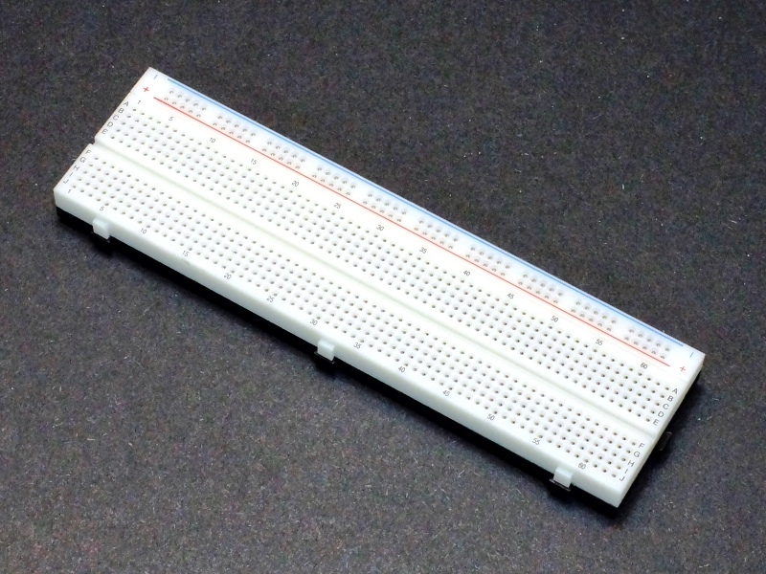A breadboard, or protoboard, is a construction base for prototyping of electronics. Originally the word referred to a literal bread board, a polished piece of wood used when slicing bread.

**Fig.3.1 Bread board**

**3.2 CONNECTING WIRES:**

Connecting wires allows an electrical current to travel from one point on a circuit to another because electricity needs a medium through which it can move. Most of the connecting wires are up of copper or aluminium.

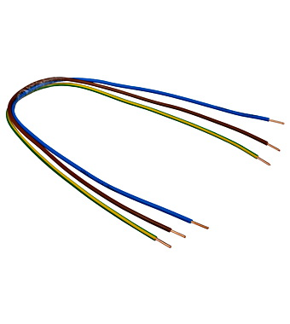

**Fig.3.2 Connecting wires**

**3.3 CONDENSER MICROPHONE:**

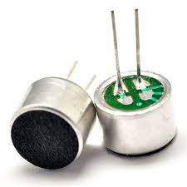A microphone is an acoustic to electric transducer or sensor that converts sound into an electrical signal. The condenser microphone, invented at Bell Labs in 1916 by E. C. Wente is also called a capacitor microphone or electrostatic microphone. Here, the diaphragm acts as one plate of a capacitor, and the vibrations produce changes in the distance between the plates. The voltage maintained across the capacitor plates changes with the vibrations in the air, according to the capacitance equation (C = Q / V), where Q = charge in coulombs, C = capacitance in farads and V = potential difference in volts. The capacitance of the plates is inversely proportional to the distance between them for a parallel plate capacitor.

**Fig 3.3 Condenser microphone**

**3.4 BATTERY(9V):**

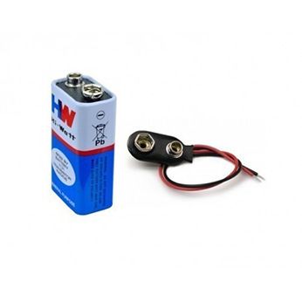A battery is a source of electric power consisting of one or more electrochemical cells with external connections for powering electrical devices such as flashlights, mobile phones, and electric cars.

**Fig.3.4 Battery**

**3.5 BC547B TRANSISTOR:**

The BC547 transistor is an NPN transistor. A transistor is nothing but the transfer of resistance which is used for amplifying the current. A small current of the base terminal of this transistor will control the large current of emitter and base terminals. The main function of this transistor is to amplify as well as switching purposes. The maximum gain current of this transistor is 800A.

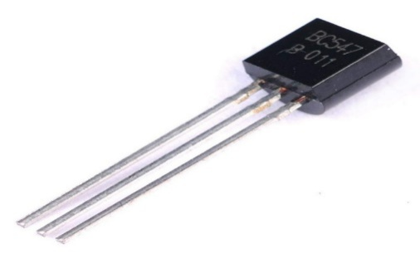

**Fig.3.5 Transistor**

**3.6 LED:**

A **light-emitting diode** (**LED**) is a [semiconductor](https://en.wikipedia.org/wiki/Semiconductor) [light](https://en.wikipedia.org/wiki/Light_source) [source](https://en.wikipedia.org/wiki/Light_source) that emits light when [current](https://en.wikipedia.org/wiki/Electric_current) flows through it. [Electrons](https://en.wikipedia.org/wiki/Electron) in the semiconductor recombine with [electron](https://en.wikipedia.org/wiki/Electron_hole) [holes](https://en.wikipedia.org/wiki/Electron_hole), releasing energy in the form of [photons.](https://en.wikipedia.org/wiki/Photon) The colour of the light (corresponding to the energy of the photons) is determined by the energy required for electrons to cross the [band](https://en.wikipedia.org/wiki/Band_gap) [gap](https://en.wikipedia.org/wiki/Band_gap) of the semiconductor. White light is obtained by using multiple semiconductors or a layer of lightemitting phosphor on the semiconductor device.



**Fig 3.6 Led**

**3.7 RESISTOR:**

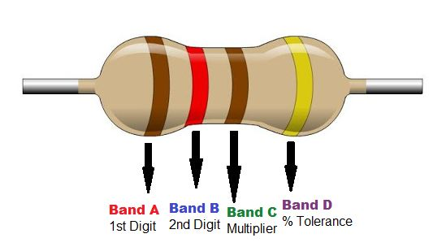A resistor is a passive electrical component with two terminals that are used for either limiting or regulating the flow of electric current in electrical circuits.The main purpose of resistor is to reduce the current flow and to lower the voltage in any particular portion of the circuit. It is made of copper wires which is coiled around a ceramic rod and the outer part of the resistor is coated with an insulating paint.The terminals of the resistor are each of the lines extending from the squiggle (or rectangle). Those are what connect to the rest of the circuit. The resistor circuit symbols are usually enhanced with both a resistance value and a name. The value, displayed in ohms, is obviously critical for both evaluating and actually constructing the circuit.

**Fig 3.7 Resistor**

The resistors we use in Sound Reactive LEDare:

* 1M ohm
* 22k ohm
* 10k ohm

**CHAPTER 4**

**BACKGROUND THEORY**

An electronic device that can control light appliances by users clap action is a clap switch. It was invented by R Carlile, Stevens, and E Dale Reamer on 20th February 1996. The main advantage of this technology is that it is mainly helpful for a mobility-impaired person. The condenser mic is one of the main components in the circuit that tracks the input clap sound based on the pitch of clap and transduces this [sound energy](https://www.elprocus.com/ultrasonic-detection-basics-application/) into some electric pulses. These electric pulses are the desired input to the Sound Reactive LED.

The Sound Reactive LED is based on you clap or any sound of approximately same pitch of Clap sound. this sound signal is converted into the electrical signal by the condenser microphone.These sound vibrations are given to the inverting input of IC 741 and Its amplifies the sound collected by the Microphone.Resistor R1,R2 and VR2 variable resistor adjust the sensitivity of the amplifier.Resistor R3 set the sensitivity of Microphone.The amplified output pulses from IC1 (IC 741)  passes to the input of  IC2 (CD 4017). CD4017 receives a clock signal through the clock input and it turns ON all the 10 outputs one by one, every time it gets the clock input pulse.When you clap once, the relay is activated and the Fan (or any load) is turned ON. When you clap for the second time, the relay is deactivated and the Fan is turned OFF.

**CHAPTER 5**

**CIRCUIT DIAGRAM**

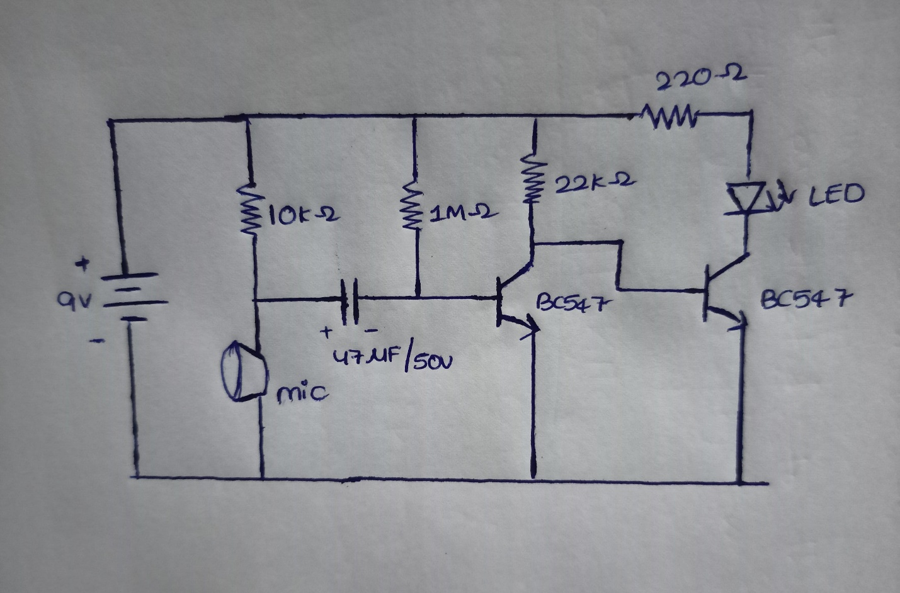

**FIG : 5.1 : CIRCUIT DAIGRAM**

The above diagram is the circuit diagram of Sound Reactive LED. In this BC547B transistor acts as a switch and its emitter terminal is connected to terminal is connected to power supply and negative terminal to transistor .So when sound is detected by the condenser mic the led will be glown and after few seconds it turns off automatically. **CHAPTER-6**

**WORKING**

This circuit uses a sound-activated sensor as an input to detect the clap sound & generates the output by processing the input into the circuit. When sound is given as the input to the Electric Condenser Mic, it is changed into the Electrical Energy as the LED turns on. LED turns ON, as we give sound input and it turns OFF automatically after a few seconds.

Although the name of the circuit is the Sound Reactive LED, you are not restricted to give input as the Clap only. It can be any sound, having the same pitch as of Clap so this can also be called as “Sound Operated Switch”. This circuit is mainly based on transistors because the negative terminal of Mic is directly connected with the transistor. In this circuit, we haven’t used any Electronic Switch to turn on/off the circuit, so when you are connecting the battery with the circuit, it means your circuit is now turned ON and it will take the inputs in the form of Sound Energy. You can modify this circuit by using Relay as Electronic Switch to turn the circuit ON or OFF.

As soon as we give the sound input to the circuit, it amplifies the sound signals and proceeds them to the LED, making it turn ON. You are to make sure, that the negative side of the Condenser mic is connected with the amplifier or the circuit will heat-up and may not work with different models of transistors etc. You cannot increase the sensitivity of the Condenser mic for long usage, it has a short range by default. It is also applicable to the LAMP and fans and other electrical appliances, so this circuit has many opportunities for modification.

**CHAPTER 7**

**RESULTS AND OUTPUT**

**The experimental results obtained from the project are described as below:**

**Case1:** The below fig 7.1 shows how the components are connected according to circuit diagram.

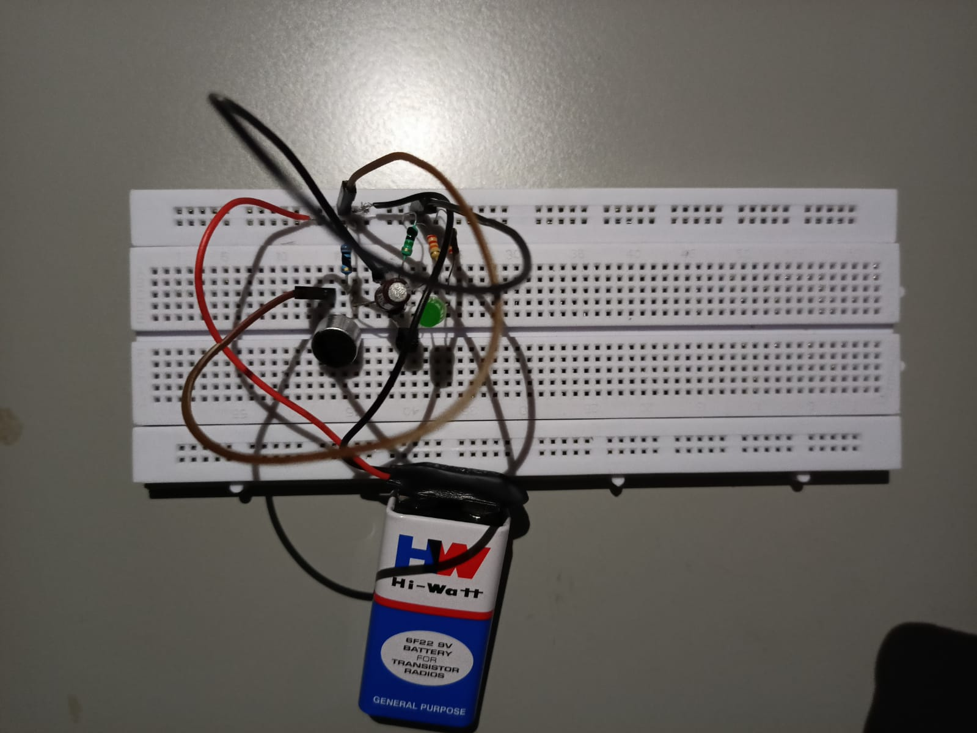

**Fig :7.1 Sound Reactive LED connections**

**Case2:** When there is a clap detected by condenser Mic, the sound energy changed into the Electrical Energy and the LED turns onas shown in fig7.2

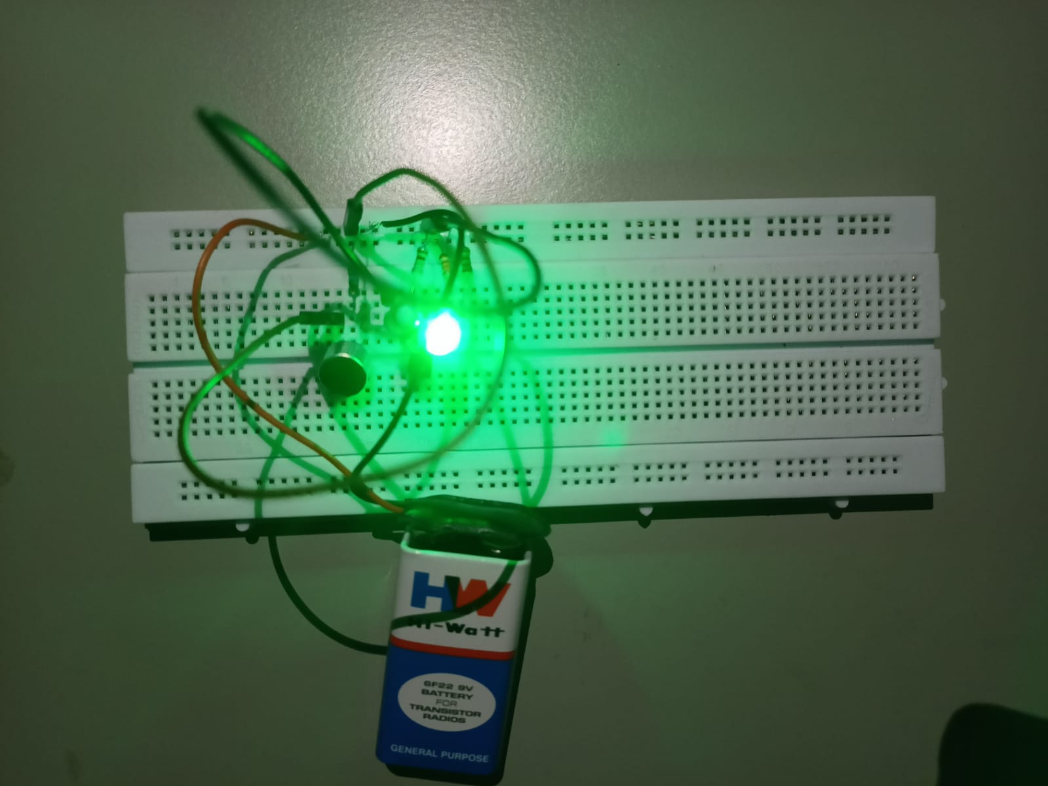

**fig.:7.2 Sound Reactive LED output**

**Case 3:** After few seconds the LED automatically turns off as shown in fig 7.3



**fig.:7.3 Sound Reactive LED output**

**CHAPTER 8**

**CONCLUSION**

The clap activated switching device function properly by responding to both hand claps at about three to four meter away and finger tap sound at very close range, since both are low frequency sounds and produce the same pulse wave features. The resulting device is realizable, has good reliability and it's relatively inexpensive. Assemble the circuit on a general-purpose PCB and enclose it in a suitable box. This circuit is very useful in field of electronic circuits. By using some modification it area of application can be extended in various fields. It can be used to raised alarm in security system with a noise and also used at the place where silence needed.

**CHAPTER-9**

**REFERENCES**

* <https://www.watelectronics.com/clap-switch/>
* <https://www.electricaltechnology.org/2014/10/clap-switch-circuit-electronic-project.html>
* <https://circuitdigest.com/electronic-circuits/clap-switch-project>